Arranger Certification Program
Application

Name Membership #

Chapter Name Region #

Address City/State

Zip Fax Email

Home Phone Alternate Phone

Sweet Adelines International Experience

□ Chorus Director/Co-director □ International Faculty
□ Associate/Assistant Director □ Judge (Category) __________
□ Section Leader □ Quartet Member
□ Regional Leader □ Quartet Coach
□ Arranger □ Chorus Coach
□ Other

Musical Background

Formal education:

Other musical training:

Barbershop experience outside Sweet Adelines International:

Please list membership in other musical organizations (e.g., NAfME, ACDA, NATS):

Signature Date

Please complete and return this application to international headquarters, along with the $100 USD application fee by check, money order payable to Sweet Adelines International, or by credit card (see below). FOR ONLINE PAYMENTS: To pay online, please email education@sweetadelines.com to request an invoice to submit your payment. (This fee is non-refundable and non-transferrable.)
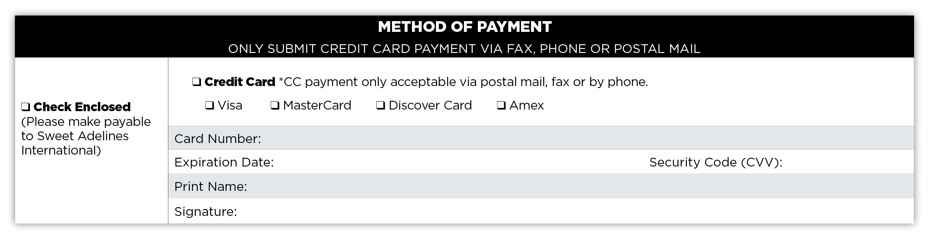
PLEASE NOTE: The application fee to enroll in the Arranger Certification Program does not include the Arranger Guide which can be purchased through SA sales.

Sweet Adelines International ● 9110 S. Toledo Ave. ● Tulsa, Oklahoma 74137
918-622-1444 ● 800-992-7464 ● Fax 918-665-0894 ● education@sweetadelines.com

